Օրինաչափություններ

1․ Ըստ օրինաչափության՝ գտի՛ր տրված հաջորդականության հերթական անդամը։
1, 4, 7, 10, 13, 16, 19
244, 246, 248, 250
1, 2, 3, 5, 8, 13, 18
1, 4, 9, 14, 19
3, 6, 12, 2 4, 48, 96
78, 71, 64, 57, 80
147, 136, 125, 114, 103
2․ Ի՞նչ թիվ պետք է գրել բաց թողնված տեղում։ 1.11, 2.3

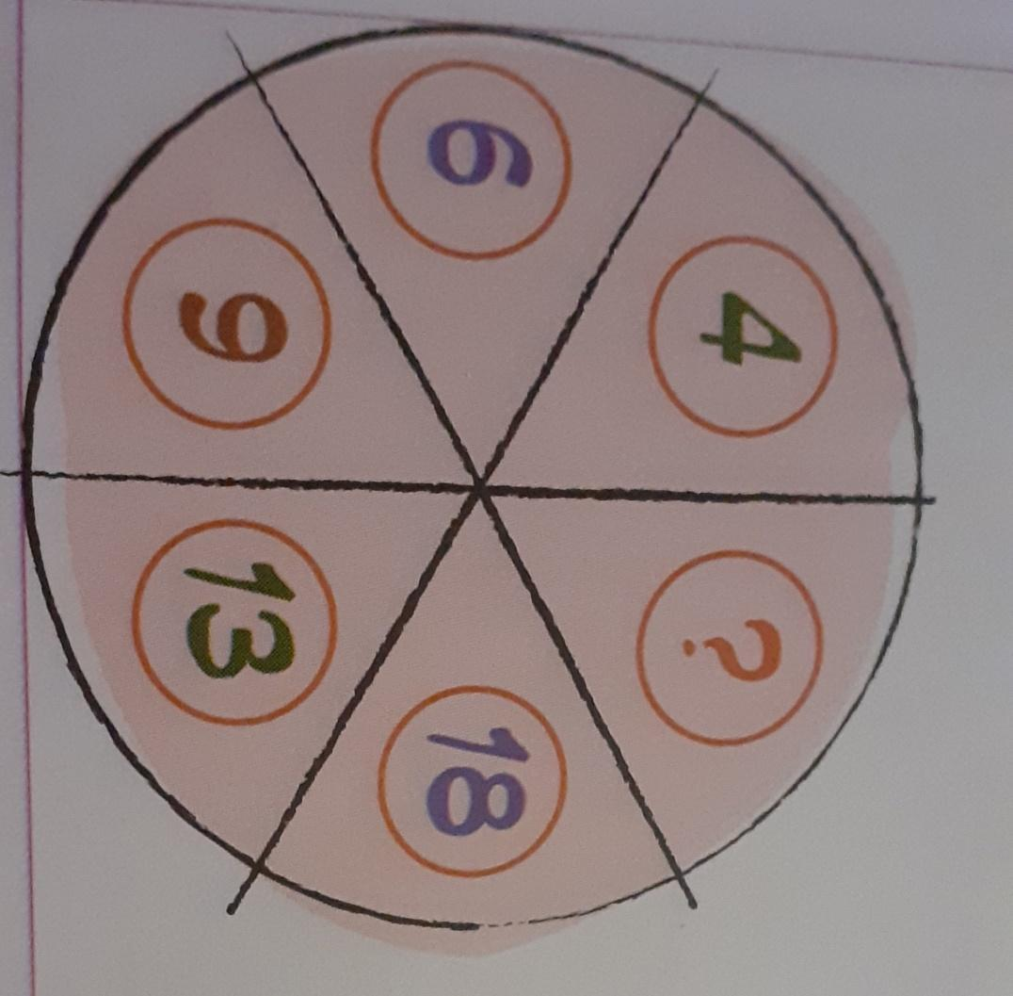

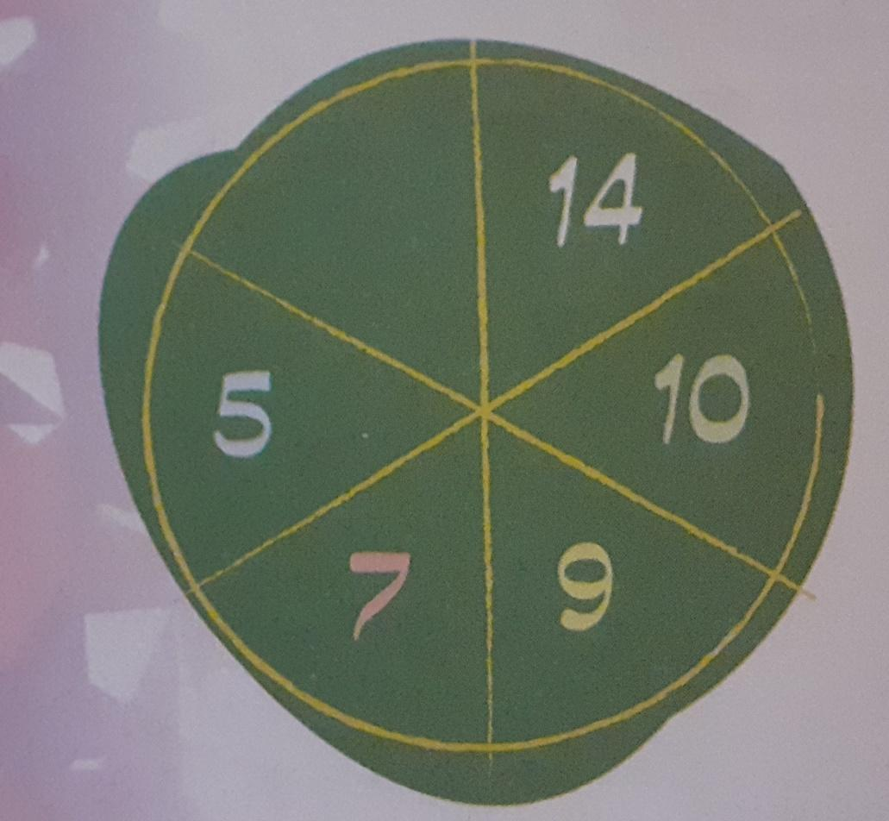

3․ Ուշադիր նայիր և գտիր, թե որոնք են հաջորդ թվերը
1, 2, 2, 3, 3, 3, 4, 4, 4, 4
4․ Ըստ օրինաչափության՝ գտիր տրված հաջորդականության
հերթական անդամը 1,4,5,9,14, 15
5․ Ստեղծիր քո օրինաչափությունը
2, 6, 8, 10

