Բազմապատկման զուգորդական հատկությունը
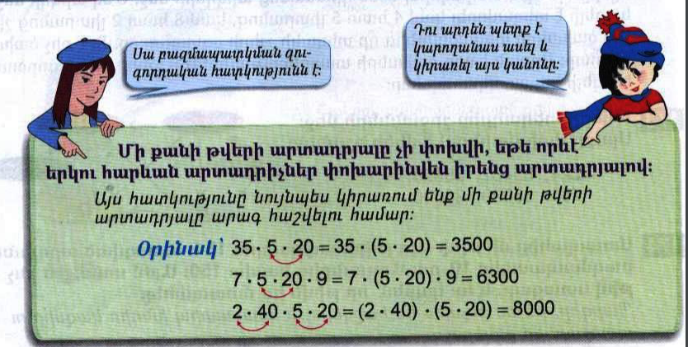

Դասարանական առաջադրանքներ
1․ Հաշվի՛ր օգտվելով բազմապատկման զուգորդական հատկությունից։
7x60x5=210000
172x2x5=1720
6x5x6x5x6x5=270000
2x4x3x2+6x7x5x2=468
2. Վերականգնի՛ր հավասարությունները
2կմ= 800 +1կմ200մ
8կմ= 3կմ100մ + 4կմ900մ
6կմ= 5կմ997մ50սմ + 2մ50սմ
12սմ = 1սմ4մլ + 10սմ6մմ
14դմ= 3դմ3սմ +10դմ7սմ
3․ Համեմատի՛ր
12տ40կգ < 12տ4ց
11ց65կգ < 1տ70կգ
4․ Դպրոցում սովորում է 450 աշակերտ։ Աղջիկները 12-ով քիչ են տղաներից։ Քանի՞ տղա է սովորում այդ դպրոցում։ 450-12=438, 438:2=219, 219+12=231
5․ 2 պարկերից առաջինում կար 27կգ ալյուր։ Երբ վաճառողը այդ պարկից 5 կգ վաճառեց և 3 կգ լցրեց երկրորդի մեջ, ապա պարկերում ալյուրի քանակները հավասարվեցին։ Որքա՞ն ալյուր կար երկրորդ պարկում։ 16
6․ Գտի՛ր այն թվերը, որոնց տարբերութունը 451 է, իսկ գումարը՝ 1451։ 951
Տնային առաջադրանքներ
1․ Հաշվի՛ր օգտվելով բազմապատկման զուգորդական հատկությունից։
7x60x5=2100
172x2x5=1720
6x5x6x5x6x5=270000
2x4x3x2+6x7x5x2=488
2. Վերականգնի՛ր հավասարությունները
2կմ350մ+ 650մ =3կմ
7կմ550մ+ 2կմ 450մ =10կմ
2մ25սմ + 75սմ = 3մ
2սմ2մմ+ 14սմ 98մմ = 15սմ
2մ7դմ + 15մ 3դմ = 18մ
3․ Համեմատի՛ր
5կգ600գ < 6կգ500գ
23կմ30մ < 30կմ23մ
12դմ5դմ < 10դմ8դմ
4․ Շաբաթօրյակին մասնակցում էին 125 աշակերտ։ Աղջիկները 11-ով շատ էին տցաներից։ Քանի՞ աղջիկ էր մասնակցում այդ շաբաթօրյակին։ 4․ Շաբաթօրյակին մասնակցում էին 125 աշակերտ։ Աղջիկները 11-ով շատ էին տցաներից։ Քանի՞ աղջիկ էր մասնակցում այդ շաբաթօրյակին։
125 – 11 = 114
114 ։ 2 = 57
57 + 11 = 68

5․ 2 պարկերից առաջինում կար 24կգ ալյուր։ Երբ վաճառողը այդ պարկից 4 կգ լցրեց երկրորդի մեջ, ապա պարկերում ալյուրի քանակները հավասարվեցին։ Որքա՞ն ալյուր կար երկրորդ պարկում։ 24 – 4 = 20
6․ 280 տեղանոց դահլիճում համերգի ժամանակ զբաղեցված տեղերը 120-ով շատ էին ազատ տեղերից։ Հաշվի՛ր մուտքի տոմսի արժեքը՝ գիտենալով, որ այդ օրվա վաճառված տոմսերի ընդհանուր գումարը 120000 դրամ է։ 300

